(Approx. 631 words)

Making Room on a Full Hard Drive
By Hewie Poplock, Member, Sarasota Technology Users Group
May 2018 issue, STUGMonitor
www.thestug.org
Hewie (at) Hewie.net

I was starting to panic. My C-Drive on my main computer was becoming unsafe as I was using up all its free space. The drive is a 240GB SSD card. I was down to 8GB free. I also have a 1 TB hard drive that is dedicated to data and designated as D-Drive.

As I saw the shrinking drive develop, I changed the default locations for such items as Documents, Downloads, Videos, & Pictures to the D-Drive. Other than Windows and programs (Apps), there is not much else on the C-Drive. The D-Drive is about 2/3 full, with about 275GB free space. The only other data that is still moveable is Evernote data which is about 7.5GB on the C-Drive, and, through its software, it can be moved to the D-Drive.

The computer was built for me over 3 years ago and originally had Windows 8.1 as the OS. AOMEI Recovery software was installed in its own 30GB partition. Since I have never needed this now outdated program, I should be able to delete the program and use that space as part of the C-Drive.

I double-checked with my vendor, SmartGuys Computers, in Sanford, Florida. They said I could uninstall the recovery software and, using Windows Disk Management, add that partition to the C- Drive. They were mostly right. I was able to uninstall the software and unallocate the 30GB partition, but Disk Management would only add that 30GB if it was adjacent to the current 193GB C-Drive. It was not. There was a 455MB partition between them. Disk Management does not move partitions.
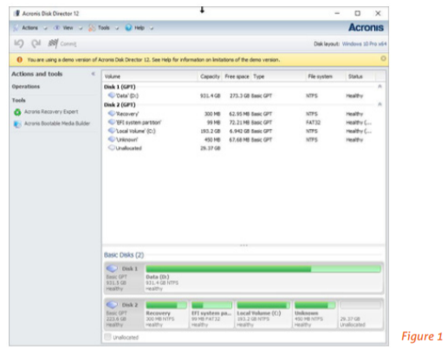
After attending User Group presentations by Gene Barlow [ http://ugr7.com ] over many years, I recalled that Acronis Disk Director should accomplish what I needed to do. My first chore was to completely back up my system. I used Acronis True Image 2018 and backed up an image of both my C-Drive & D-Drive (240 SSD & 1TB HD). I did so BEFORE removing the recovery software and unallocating that partition. I then downloaded and installed the trial version of Acronis Disk Director & its documentation to see if it would do the job. It looked like I needed to do 2 steps, but it would work. I then purchased the software from Gene Barlow, as he has special User Group member pricing. I had the key to register the software within a few hours of the purchase.

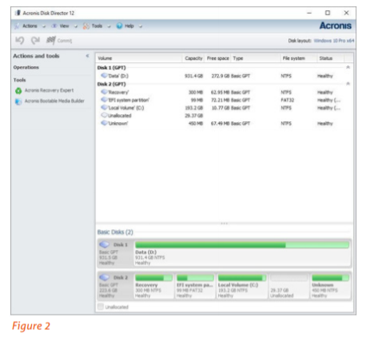
The first step was to move the 450MB partition to the end of the drive and make the 30GB unallocated partition contiguous to the C-Drive. Following the directions, this was an easy step and the move was successful.

I am not sure if the 455 MG space was needed, but looking at some articles, it appeared that there usually was an empty recovery partition at the beginning and end of a boot drive. So, I left it. The next step was to expand the C-Drive to include the 30GB unallocated space. This step was easy to set up, again following directions in the user guide. It took only seconds, and now I had 40 GB of free space on my C-Drive.

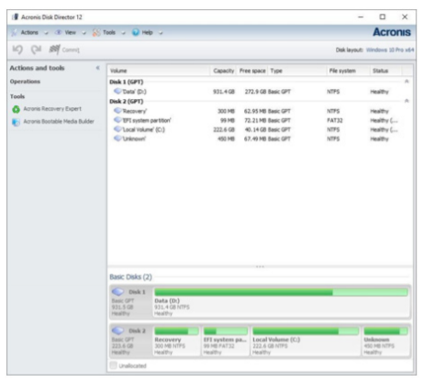
My next step is to do an image backup of the SSD drive so that I have a current backup. I will not overwrite the last backup, but save a new one, just in case I have some issues appear. After that, I will move the Evernote files and change its default to the D-Drive. I now will have enough room on my C-Drive to do the next major Windows 10 upgrade and have some room to install some new apps as needed or
wanted.

